**Gaia/Elven Knight mini-overview on builds / rotations:**

-hastily thrown up by Shiralia (Solali)

-updated for 3a

**General tips/notes:**

Gaia’s unique mechanic, Chain Rush (CR), allows her to cancel 99% of her attacks into the next with a CR inbetween. This means that optimally, you will always want to be doing CRs between as many things as possible, while hopefully being accurate.

The exception to this is Chain Strike, which ends all stacks of CR (unless you have the Talisman). In general, finish off with this skill, or use it when your low CD skills are ready so that you can quickly ramp back up to 6 chain stacks.

Putting this all together, this means that optimal rotations with Gaia would mean using low cd, “trash” skills to quickly ramp up chain stacks to 6, then using actual cube skills afterwards, and weaving in more low CD “trash” skills to keep the chain going inbetween “actual” cube skills.

**How to safeguard against Chain Rush downtime**

Because no one’s perfect, and because it’s humanly impossible to hit every CR all the time against bosses moving around, it’s important to know which “trash” skills you have on standby to immediately amp back up to 6 the moment you miss so that your cube skills dont miss out on the damage.

In addition, since it gets super intense to keep it going for long periods of time, some of her channeled skills (Nature’s Fury especially, and Lunge Evolution if you don’t have the Talisman) can let you take a moment’s rest since you don’t want to cancel their moves into CR early. I thus recommend ending with some longer channeled moves to sort of “break” to keep the hard CRs (max stacks) going. If you feel like the boss is about to move away and it’s about to end, end your CR with Chain Strike immediately and then proceed back to doing trash skills to ramp up CR again.

Because of all the trash skills you’ll need to use, I highly recommend using them as the hotkey moves, and having manual inputs for a couple of the cube skills. You can buffer input them in the middle of the animations of some of the other skills/CR, so it’s not *as* difficult as it could be.

**Weapons:**

Gaia can use the great Deus Imagery! Unfortunately, there’s no 3a out yet to really abuse this, but it’s still the best option. Since CR cancels animations, we don’t really care about attack speed, or anything of the like, so Zanbato is 100% the way to go, for more attack. Pandemonium Flame is also not terrible if you don’t have Deus. I’ve not tried Kasim’s, but Gaia’s more of a sandbag character anyways, specializing in doing big groggy damage (in theory), so you want to maximize with Deus regardless.

**Skill Building**

Unlike a lot of other classes, Gaia wants a single point in a lot of low level skills (“Trash” skills), in order to build up CR. I personally have a point in most except Finish and Intercept, since I prefer other skills to build up over Finish’s wonky movement (and Intercept being a useless anti air/leap attack that you can’t cancel properly). The other notable skill would be Ancient Boar as the “mobility” skill for moving across quickly.

Past the usual cube max, there’s some flexibility on what to level and what to relegate to “Trash”- Overwhelm is a decent aoe skill that is hard to miss, so can keep CRs going, Natural Restraint is a hold skill with good long range (but terrible y-axis range), Verdant Sword has good damage, and Elvish Jump has good mobility and damage, but has a wonky timing due to the small charge on it. If you are maxing these, keep Harbinger of Life at 1 (aka Trash skill status). Other than that, max cube skills, green passive skills, and CR.

Do not max Impregnable Defense - keep at 1 for utility, and nothing else.

Don’t bother with any of the armor buffs except for Nature’s Protection for the super armor, which, while at times doesn’t work, is still worth it as a one point wonder. Max out War Cry still, of course.

**Guardian Rising**

It’s fun to use in dungeons, but in serious content it’s 300% useless. You can’t use your actual damaging skills in this form, it’s clunky, and the super armor’s cool but redundant with Nature’s Protection.

**Talismans:**

Gaia has some fun Talismans, and they all are “okay”. In order of usefulness, I would say the best is Vanguard Strash, then Faithful Breakthrough, then Lunge Evolution, then Pulverize, then Harbinger.

Vanguard Strash Talisman adds a decent sized AoE projectile to fire from the slash, and removes the post “rend” animation. This adds some much needed AoE to Gaia’s kit, is a little easier to time the cancel, and adds pretty good damage to a low CD cube skill.

Faithful Breakthrough Talisman adds a charging Ancient Boar skill as a projectile to fire from the broken shield, while adding even more damage. All in all, this ends up with a massive damage increase to the skill.

Lunge Evolution Talisman removes the need to hold the channel, and lets you cancel into CR as soon as the tornado appears. On paper, this sounds amazing, and usually it is pretty good - you can fit more CRs/cubes during the time you’d usually spend channeling. A lot of the times, though, you won’t get as much skills in as you’d like.

Pulverize Talisman adds an auto-home in to the downwards slash, and essentially reduce the upward slash animations into a single flip slash. This does add good damage.

Harbinger of Life Talisman adds a little bit of damage and gives a healing ring/movement speed buff to the location you land in. The utility of this is pretty minimal, as most people will just potion or get healed by the sader, so I highly recommend replacing this when you can. Even if you skill point into Harbinger I wouldn’t really use this Talisman.

**Example skill/TP build with Lunge/Vanguard/Faithful Talismans:**

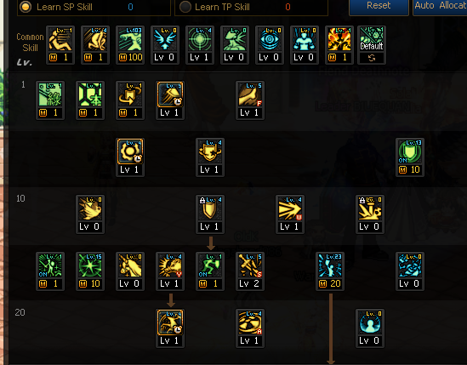

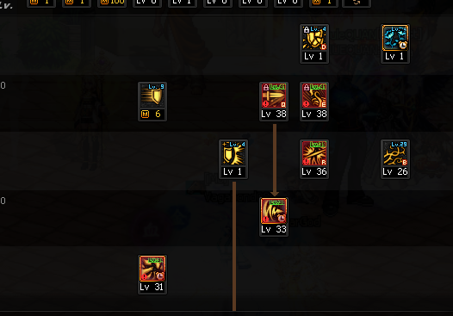

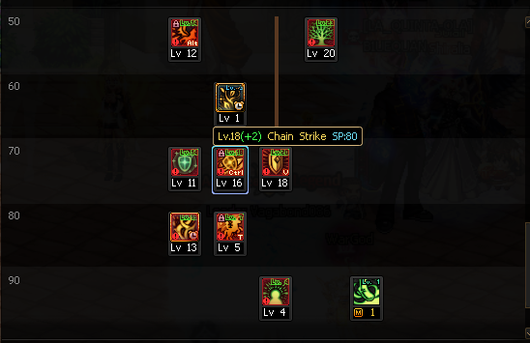

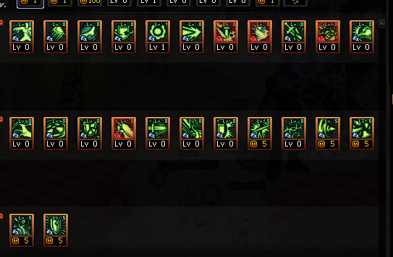



**Putting it all together:**

With the current 25s groggy standard, my current rotation looks something like this: (assume CR between each skill):

Trash x2 -> Lunge Evolution -> Verdant Sword -> Nature’s Restraint -> Elvish Jump -> Vanguard Strash -> 2a -> Trash x 5 -> Faithful Breakthrough -> Pulverize -> Elvish Jump -> Verdant Sword -> 1a -> Trash x 5 -> Harbinger of Life (basically trash skill if not used with SP) -> Chain Strike -> Trash x1 -> Elvish Jump -> Nature’s Restraint -> Vanguard Strash -> Nature’s Fury -> Lunge Evolution -> Trash x 2 -> Verdant Sword.

Note that I’ve set up “rest” points (awakenings, Chain Strike) to keep the CRs steady, and even if i miss the “Trash”’s inbetween helps ramp back up immediately. Obviously, the more you miss the more you have to add “Trash”s inbetween the cube skills.

**The notable “multi-fit” skills to keep track of:**

Lunge Evolution *can* be used twice (either have the tali or cancel early and fully channel the second, must be used super early).

Vanguard Strash can be used 2 times

Verdant Sword can be used 3 times.

Natural Restraint can be used 2 times

Elvish Jump can be used 4 times.

Try to fit as many of those in as possible, in that order of priority (depending on skill points, the priority may move up or down).